Grade 11 - What were the consequences when pseudo-scientific ideas of Race became integral to government policies and legislation in the 19th and 20th centuries?

(NB: Mote this work is already on the D)
- 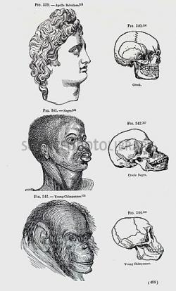
An image showing the categorisation and classification of species and races Image source
Theories and Practice
Scientific Racism
These ideas about race were divided into two main theories, scientific racism and social Darwinism. Scientific racism developed when Social Scientists, who studied human behaviour in different social contexts, believed that the same system used by Natural Scientists to classify animals and plants according particular characteristics could be used to classify and categorise human beings as well.
Social Scientists then began measuring and categorising human beings according to particular characteristics like their physical features such as skull sizes and skin colours. After this they created different types of races, where they made conclusions about typical characteristics that each of the races they established had. Each race had distinct characteristics from another race.
Europeans applied scientific racism when they met natives of their colonies. They did this to prove how superior and civilised they were compared to the natives, who according to them were uncivilized. Europeans then started measuring and categorising the natives in their colonies in order to confirm the ideas about race as developed by social scientists at that time. They would take some of these natives, sometimes features of their dead bodies like their skulls, to displays and exhibitions in Europe.
Social Darwinism
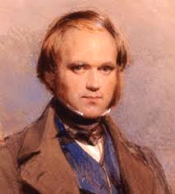British Scientist Charles Darwin who developed the theory of evolution Image source
Social Darwinism was based on the theory of evolution, which showed that different earth species such as animals and plants were constantly evolving in different stages. Some were at advanced stages, while others were still in early stages, left behind. This theory of evolution was developed by a British Scientist Charles Darwin in 1859.
This process of evolving was clearly explained by an English social scientist Herbert Spencer, who described it as “survival of the fittest “which meant that some people were at the early stages of evolution, while some were at the advance stages. He argued that was how things were supposed to be. Hence in some parts of the world some races, often Europeans, were said to be more civilized, and technologically advanced, while in some parts of the world some races, often indigenous, races were considered to be uncivilized
This theory of evolution fuelled ideas of hierarchy in races, where some races such as Whites were believed to be superior than other races like Africans, thus in light of the “Survival of the fittest” the superior population had a right to claim total dominion and control of the said to be inferior population.
Image showing stages of evolution. Image source
Eugenics
Eugenics (Greek for good genes) is a science of increasing breeding (reproduction) of the considered to be superior groups and suppressing the growth of the selected to be inferior groups in order to improve the quality of human population by getting desirable genetic characteristics.
The superior population in society was often the rich, the educated, the healthy and often a particular race like White people. The inferior on the other side was the disabled, mentally disturbed, sick, immigrants, criminals and often a particular race like Black people. Sexual relationship between the superior and the inferior was often prevented as it would mix and spoil the good bloodline that was desired.
This theory of eugenics was influenced by the increased confidence in science as the most reliable and efficient way of understanding the world which was popular in the 19th century. It was developed by the English writer Francis Galton. He believed that in the interest of “survival of the fittest” the poor and the weak should be left to remain so, as it only meant they were in the early stage of evolution, while the “superior” should be encouraged for the benefit of a good and healthy population.
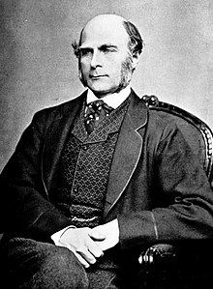Francis Galton Image source

Positive Eugenics
Eugenics played a positive role in promoting health and on family planning. Countries who believed in eugenics such as the United States of America, Britain, Sweden, India and China encouraged good health of the superior groups. They encouraged these superior groups to exercise and eat healthy. These governments did this by building public swimming pools and sport grounds for the superior groups, hoping to develop populations with good genes; they also encouraged women who were considered healthy to have children for the same purpose of getting good genes.
Negative Genes
On the other side the said to be inferior groups were sterilised, sometimes by force. For instance in USA, between 1907 and 1943, sterilization laws were passed in 30 states. This was done to prevent growth of the inferior kind. To prevent them from growing in population, the inferior population was also made to take contraceptive pills (birth control pills).
Race today
Today eugenics are discouraged, and not only considered to be wrong but also to be violating human rights. In the 1990s it was discovered that all people have a “mutual ancestor” which originated in Africa because the earliest human remains (about 200 000 years old) were found in Africa.
Scientists had also discovered that there were no fixed or consistent differences in race in terms of characteristics like physical features. In other words scientists had discovered that not all Black people have round lips, not all white people have sharper noses, and not all Asians have small eyes, as it was believed by Eugenicist in the 19th century.
Many people argue that the word 'race' should no longer be used for the following reasons:
- Most scientists today would say that there is no such thing as race.
- The misinterpretation of the term 'race' to classify people has gone hand in hand with contempt (violation) for human rights.

Race in USA
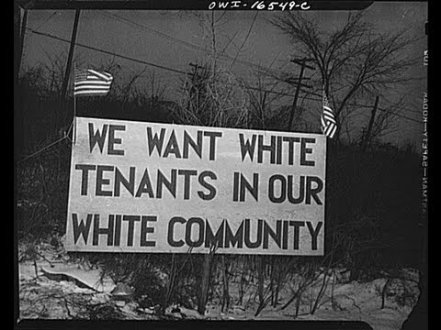A billboard in the 1950s in USA. Image source
In the 19th century Pseudo-Scientific theories about race were also used in USA. The government treated Native Americans and African Americans as inferiors, while it treated whites as superiors.
By this time (19th Century) thousands of Native Americans had been killed by starvation (excessive hunger) and the diseases that they caught from Europeans and which they were unable to treat. The white settlers had defeated Native Americans in war battles for land and had had taken their land.
On the other side, in the 1950s African Americans were discriminated against by the segregation laws that were laid in different states in USA. There were segregation laws in public facilities such as transports, schools, parks and restaurants.
African Americans’ facilities were often poor in service and in quality compared to the whites’ facilities. For instance African Americans’ schools were often over populated and lacked resources, while whites’ schools had fewer pupils in a classroom and had good infrastructure.
The inferior groups being the Native Americans and the African Americans were left to suffer with little help, if any, from the government. This was part of the “survival of the fittest” idea and was in line with the USA’s capitalist system, where certain inpiduals in society had more power in business, or politics.
Race in Namibia
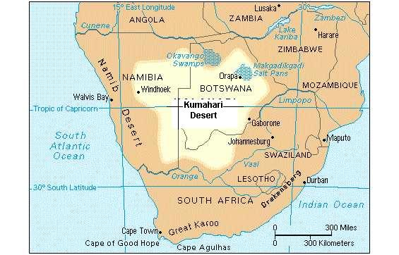A map showing the Kalahari Desert in which Herero were driven to by German colonialists. Image source
Namibia became a German colony in 1884, and was called South West Africa. The Germans had arrived in Namibia as part of European immigration to different colonies, which was popular at that time and was associated with superiority.
When they arrived in South West Africa the country was occupied by the Nama (Khoi people) and Herero farmers. The Germans then began to remove the Herero and Namas from south West Africa to the Kalahari Desert. The Hererofought back in what became known as the Herero Revolt.

Race in South Africa
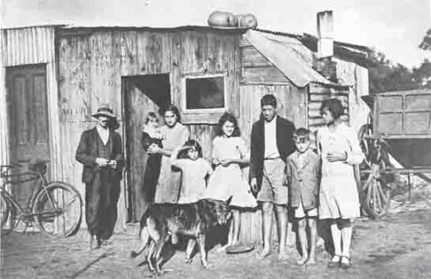Poor Afrikaners in South Africa during the 1920s. Image source
South Africa had laws that relied on eugenics as truthful facts about race. In South Africa mating and sexual intercourse between the said to be inferior groups and the superior groups was prevented because it would lead to an inferior population. These laws existed even before Apartheid in South Africa. They included the Immorality Act of 1927 which prevented sexual relationships between White and Black South Africans.
In the 1930s the South African Government controlled breeding of the inferior groups, which included poor whites (largely Afrikaners) due to the Great Depression. In the 1930s the South African government created a programme called the "Race Welfare Society" to control births among poor white females and encourage them to have smaller families that they could manage to take care of in terms of finances.
Although in the 1930s the South African Government had these laws and programmes that were fuelled by the theories of Eugenics, unlike USA it never practiced sterilisation. This was because of two reasons (i) the validity and fairness of eugenics policies was beginning to be doubted in Britain, and (ii) in the 1930s was the rise of Afrikaners to power therefore large families were encourage to make the Afrikaners nation stronger.

Case study: Australia and the indigenous Australians
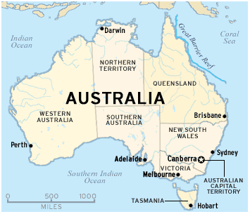A map showing Australia. Image source
The Aborigines were the indigenous people of Australia, who had lived there long before Europeans arrived. They were hunt-gatherers so they used to move around Australia in search of food and better climate.
By the 1780s the British already had plans about Australia (i) they wanted Australia to be its penal colony, where British convicts would be sent (ii) they wanted to claim Australia as its territory first before competing colonialists like France did.
The British began to put their plans into action; they cut down trees, built houses and started planting in Australia. The settlers together with their convicts first arrived at New South Wales (NSW), then to the Island of Van Diemen's Land (today known as Tasmania) and Perth (which was called the Swan River).
When gold was first discovered in Melbourne’s capital Victoria, miners from Britain, China and Ireland filled the region in search of gold. By the 1900s the British empires in Australia were already well established. In 1901 the British empires in Australia formed their own government, the Australian Federation.
The British settlers in Australia did not recognise the rights of the Aborigines by denying them their land and their food (as the British had cut all trees where Aborigines used to find food). This made the Aborigines to rely on the settlers. The Aborigines worked for the British settlers as farm labours or domestic workers. They were paid very low wages, as a result of large numbers of Aborigines became poor and were easy victims of diseases like smallpox brought by European settlers.
Thousands of Aborigines died from starvation, and diseases such as smallpox. This has left Historians debating whether these deaths of Aborigines could be blamed on Europeans as acts of genocide or whether these deaths as a result of the Aborigine’s failure to adapt to change.
Debates on racial suicide and racial decay
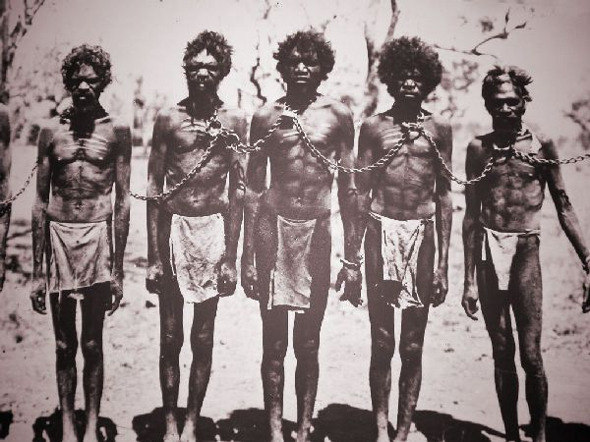Ill-treatment of the Aborigines upon the arrival of European settlers in Australia Image source
As established before that European' cruelty on Aborigines was justified by Pseudo-Scientific theories like Social Darwinism which were largely believed in the 19th century. These theories regarded the Aborigines as inferiors who were at the early stages of evolution, and who could not compete with Europeans as Europeans were at the advanced stages of development.
Some of the laws which were fuelled by Social Darwinism that were passed by the Europeans upon the Aborigines meant that the Aborigines were prohibited from voting, owning dogs and carrying guns. Intermarriage between the Aborigines and white people required special permission from the government. Aborigines were moved to reserves by force
Among Europeans there were debates on what should be done by the then believed to be valid "Social Darwinism" with regard to aborigines. a handful of Europeans wanted the Aborigines to integrate into European Society Some believe that the Aborigines should be kept in places of safety, outside the European society some felt that the Aborigines should be kept segregated from the settlers’ society because they were inferior
Extracted from: SAHISTORY .ORG
https://www.sahistory.org.za/article/grade-11-what-were-consequences-when-pseudo-scientific-ideas-race-became-integral date accessed 01/06/20
Activity
Read Sources A, B, C, and D to answer the questions that follow.
Source A

Social Darwinism is a false application of Darwin's ideas such as adaptation and natural selection, and does not really follow from Darwinian thinking in any way. .. Social Darwinism does not believe in the principle of equality of all human beings. It states that: Some human beings are biologically superior to others .The strongest or fittest should survive and flourish in society. The weak and unfit should be allowed to die. There was a constant struggle between humans and the strongest always would win. The strongest nation was the fittest, therefore the best, and consequently had an inherent right to rule. Social Darwinism applied the 'survival of the fittest' to human 'races' and said that 'might makes right'. Not only was survival of the fittest seen as something natural, but it was also morally correct. It was therefore natural, normal, and proper for the strong to thrive at the expense of the weak. White Protestant Europeans had evolved much further and faster than other "races."

http://www.sahistory.org.za/article/pseudo-scientific-racism-and-social-darwinism-grade-11#sthash.Nf2pXIjh.dpuf Accessed on 10/04/16

Source B

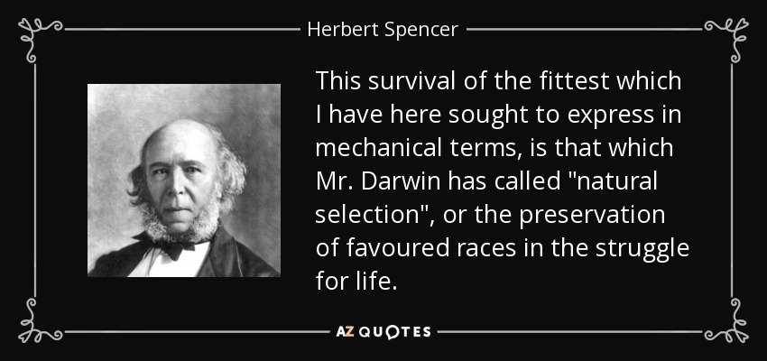

Source C

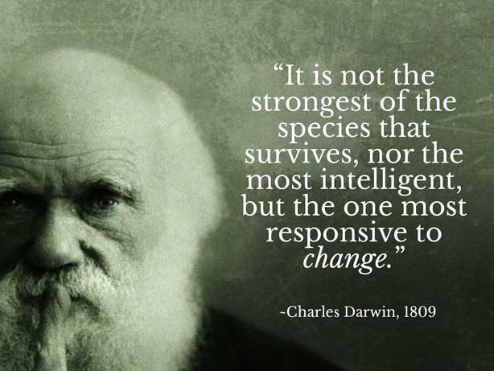

Taken from www.skeptical-science.com

SOURCE D
Charles Darwin's cousin, Francis Galton, developed a new branch of scientific enquiry based on the theories of evolution. He called it eugenics. Eugenics is the science of the improvement of the human 'race' by breeding the 'best with the best'. He believed that natural selection does not work in human societies the way it does in nature, because people interfere with the process. As a result, the fittest do not always survive. From this point, it was an easy step for some governments to become actively involved in promoting biological engineering, encouraging 'superior' elements of society to have more children and preventing 'inferior' elements from having children, in euthanasia and sterilisation programmes for the mentally ill, disabled and mixed-race children, as happened in the USA and Nazi Germany. In 1904 Galton explained how he believed eugenics would improve a human stock:
The eugenics is the science which deals with all influences that improve and develop the inborn qualities of a race. But what is meant by 'improvement'? We must leave morals as far as possible out of the discussion, on account of the almost hopeless difficulties, they raise as to whether a character as a whole is good or bad. The essentials of eugenics may, however, be easily defined. All would agree that it was better to be healthy than sick, vigorous than weak, well fitted than ill fitted for their part in life. In short, that it was better to be good rather than bad specimens of their kind, whatever that kind might be. There are a vast number of conflicting ideals, of alternative characters, of incompatible civilisations, which are wanted to give fullness and interest to life. The aim of eugenics is to represent each class or sect by its best specimens, causing them to contribute more than their proportion to the next generation. That done, to leave them to work out their common civilisation in their own way ... eugenics co-operates with the workings of nature by ensuring that humanity shall be represented by the fittest races. What nature does blindly, slowly, and ruthlessly, man may do providently, quickly and kindly ... . The improvement of our stock seems one of the highest objects that can be reasonably attempted.

Source E
This illustration is to show all the areas in which United States eugenicists thought that eugenics would be useful. These areas are listed on the roots of the tree. They thought that if eugenics were followed, a better and more harmonious society would be the result. This illustration is from the American Philosophical Society

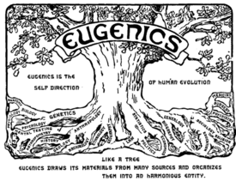

Questions
DO NOT SUBMIT YOUR ANSWERS. ANSWERS WILL BE UPLOADED FOR SELF MARKING

  - Refer to source A
    - What are the main beliefs of Social Darwinism? (2x2)(4)
    - According to this source is Social Darwinism supported by Darwinism? (1x1) explain your answer. (2x2)(1+4=5)
    - How would the phrase “might is right” justify
- colonialism (2x2)(4)
- genocide (2x2)(4)
  - Refer to source B
    - According to Spencer, how does survival of the fittest tie into Darwin’s theory of evolution? . (2x2)(4)
    - How is source A supported by the evidence in source B? (2x2)(4)
    - Which source is the most reliable, source A or source B? (1x1) Explain your answer (2x2)(1+4=5)

  - Refer to source C
    - In your own words, explain what Darwin is saying in this source? (1x2)(2)
    - Does this support or contradict Spencer’s statement in source B? (1x1)(1) Explain your answer. (2x2) (4)
    - How does source C support source A? (2x2)(4)
  - Refer to source D
    - In your own words define the concept eugenics. (2 x 2)(4)
    - Explain whether eugenics can be supported as a science. (2 x 2)(4)
    - What, according to this source, was the aim of eugenics? (1 x 2)(2)
    - Explain why you would agree or disagree with the following statement:
‘... eugenics co-operates with the workings of nature by ensuring that humanity shall be represented by the fittest race’. (2 x 2)(4)
  - Refer to source E
    - What does this illustration say about eugenics? (2 x 2)(4)
    - Explain whether the tree is an accurate representation of eugenics. (2 x 2)(2)
    - The eugenics movement stated that if its philosophy were followed 'a better and more harmonious society would be created'. To what extent do you support this statement? (3 x2)(6)
1.5.4 How, do you think, physically challenged (disabled) persons would react to the philosophy of eugenics? (2 x 2) (4)
DO NOT SUBMIT YOUR ANSWERS. ANSWERS WILL BE UPLOADED FOR SELF MARKING

